Jonathan Quang 3/16/15

Prelab #5 SLS44-09/Period 4,5

1. Compare and contrast angiosperms to gymnosperms.

Angiosperms and gymnosperms contain several similarities and differences. Both are in the domain Eukarya and the kingdom plantea. In addition, angiosperms are plants whose seeds are enclosed in ovaries where as the seeds of gymnosperms are unenclosed. The leaves of angiosperms are flat while the leaves of gymnosperms are needle-like.

2. The flower attaches to what part of the plant?

The flower attaches to the receptacle of the plant, which is an enlarged area at the apex of the stem.

3. Why are flowers brightly colored?

Flowers are brightly colored because they attract animals that may assist in spreading seeds or pollen.

4. The female reproductive structures are called the:

The female reproductive structures are called the pistil.

5. Name the three parts of the pistil:

The three parts of the pistil are the stigma, style, and ovary.

6. Where are the ovules stored?

The ovules are stored in the ovary.

7. Name the two parts of the stamen:

The two parts of the stamen are the anther and filament

8. Describe sexual reproduction in plants.

Pollen travels from the male stamen part of one flower to the stigma of the female part of the same or another flower.

9. The ovary develops into what structure and why does this occur?

The ovary develops into fruit because the fertilized ova inside the ovary prompts the ovary to begin swelling into a fruit. Fruits make it easier for seed dispersal to happen, possibly by attracting animals or setting up for an "explosive" dispersal.

10. Some flowers are not brightly colored at all, but have a very pungent odor that smells like rotting meat. How do you think these flowers are pollinated?

These flowers are pollinated by flies and other insects that eat decaying organic matter. They would be attracted to the smell of rotting meet, and upon going into the flower, pollen may be stuck to the insect.

11. In many flowers, the pistils and stamens reach maturity at different times. Considering what you know about pollination, why would this be an advantage to the plant?

The difference in maturation time between the pistil and stamens offer an advantage to the plant because this prevents the pollen of the plant from fertilizing itself.

12. How are fruits useful to plants?

Fruits are useful to plants make it easier for seed dispersal to happen by attracting animals, deterring animals that eat the seeds, or by setting up for an "explosive" dispersal by building up pressure within the fruit.

13. How is a **BERRY** different from a **DRUPE**? Describe and give an example of each.

A berry is a round, juicy fruit that contains multiple seeds where as a drupe is a fleshy fruit with thin skin and a central seed covered in hard endocarp. An example of a berry is a grape and an example of a drupe is a cherry.

14. Describe what occurs when a seed germinates. What environmental conditions are needed to begin the germination process?

When a seed germinates, water enters the seed coat causing the pressure to rise. As a result of the expanding, the seed shell cracks. The shoot/pumule and the radical will begin to sprout afterwards.

15. Label the diagrams below.

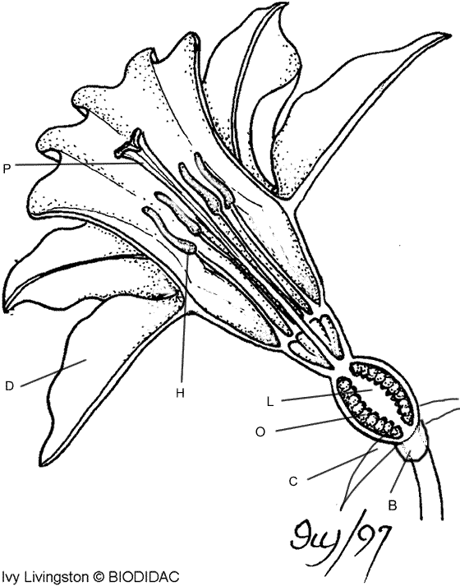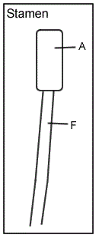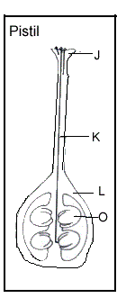

A: Filament

F: Anther

J: Stigma

K:style

L:Ovary

O:Ovules

P: Pistil

D: Petals

H: Stamen

L: Ovary

O: Ovules

C: Sepals

B:Receptacble